Bid Proposal

2015 F-18 World Championship Regatta

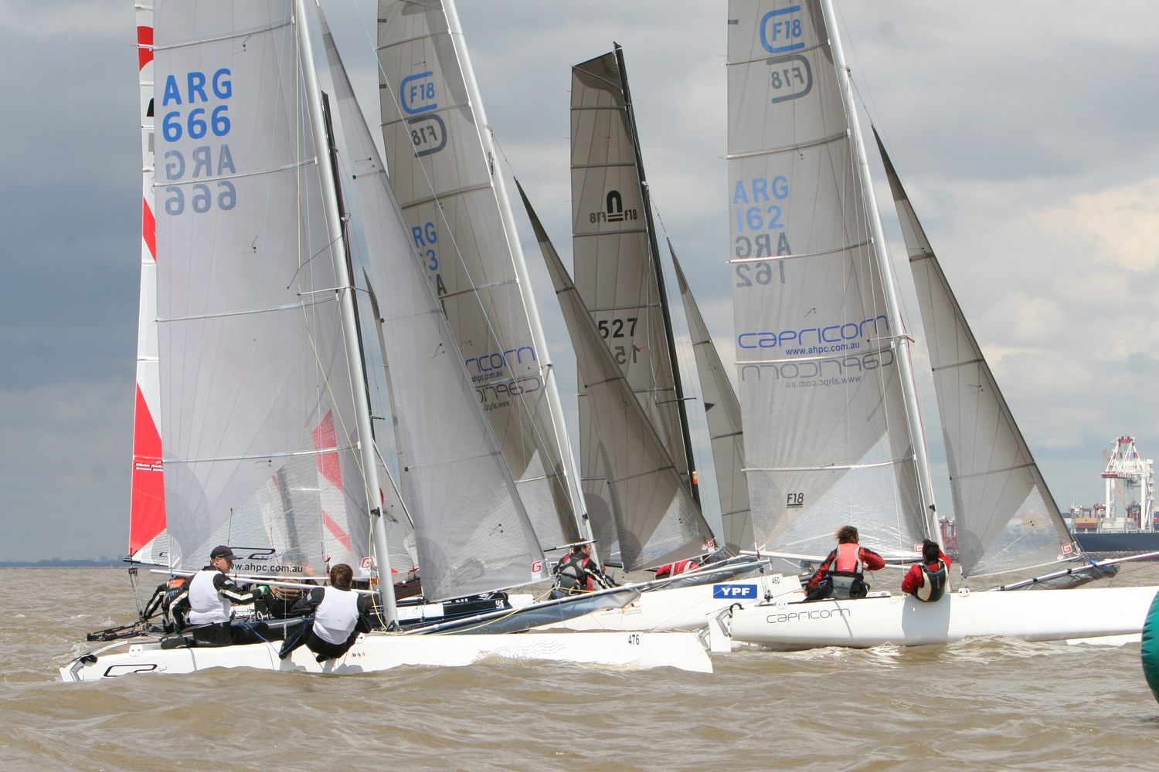

Submitted By:

YACHT CLUB ARGENTINO
ASOCIACIÓN FÓRMULA F-18 ARGENTINA

Table of Contents

Introduction ...................................................................................................................

General Information.......................................................................................................

Sailing Environment ......................................................................................................

Entry Fee ........................................................................................................................

Race Management ..........................................................................................................

Boats & Other Marine Related .......................................................................................

Accommodation..............................................................................................................

Miscellaneous ................................................................................................................

Appendix A: Buenos Aires Information…........................................................................

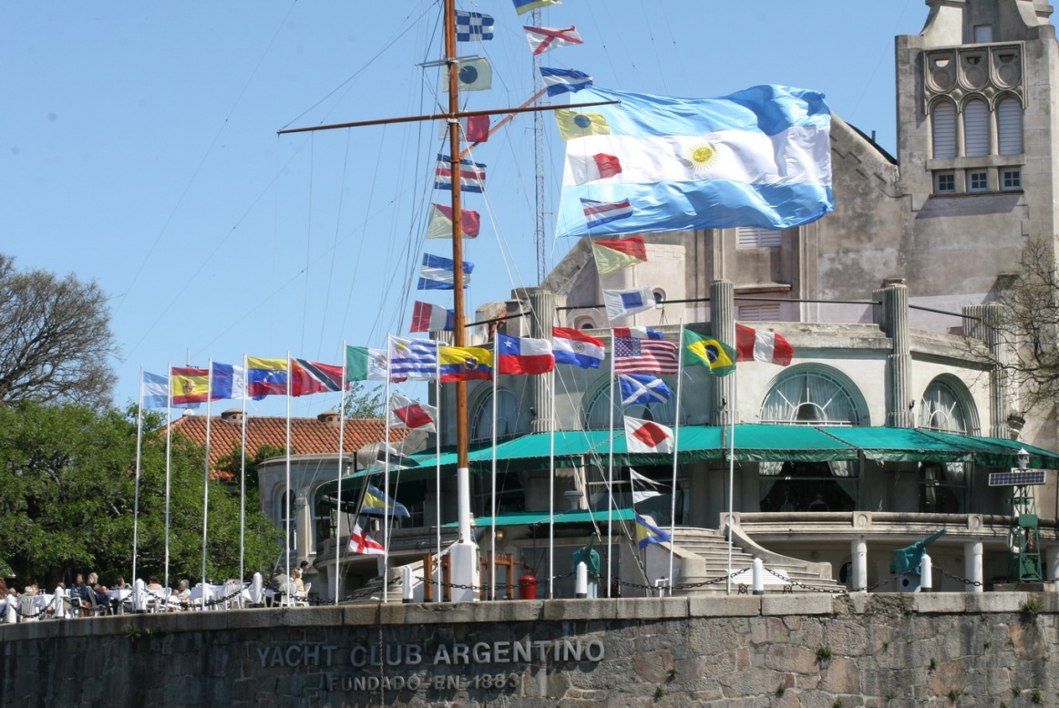
Introduction

The Asociación Fórmula F-18 Argentina in conjunction with the YCA Yacht Club Argentino, would like to host the 2015 World Championship Regatta.

The YCA have the necessary resources and track record to insure that a regatta of the highest caliber is held.

We would like to host the 2015 F-18 World Championship on November, this is a great time of the year for sailing in Buenos Aires and it is only two weeks after “Semana de Buenos Aires” that it is the most important Championship in South America for dinghies, and one of the few in the world that brings together 23 classes simultaneously in a single seat with closed park.

Buenos Aires offers a wide variety of wind ranges and challenging conditions which make its Rio de la Plata, the world’s widest river, one of the best places to sail. Enough space is available to keep race courses away from nautical routes and the location of the club gives the P.R.O. 3 miles of clear water in all directions.

As the host yacht club, YCA will be part of the organizing authority. The club has a proven ability to organize all aspects of major sailing and social events and with its “full agenda” calendar is among the upper echelon of yacht clubs with active racing programs. On-the-water activities YCA have dedicated internationally and nationally certified race management personnel.

Competitors will find Buenos Aires an interesting, convenient, and accommodating location for a regatta. This is a unique city that suits every visitor because it combines varied experiences. From going to a soccer match to dancing tango, the tourists can experience the city in many different ways.

There are approximately 40 hotels for every budget 15 minutes walking from the regatta center , what is more, the City of Buenos Aires has approx 211 1 to 5-star hotels and apart hotels, which translates into 36,000 rooms.
The town offers visitors a variety of shopping, entertainment, and dining all within walking distance of the yacht club.

Dársena Norte YCA´s quarter house will be the home base for the event; its allocation is more than convenient as it is in the most strategy point of the city, within 15 minutes walking visitors can reach the Port as well as the historical and commercial center of Buenos Aires.

The regatta center has all the facilities necessary to host the event including three hoists, room for measurement activities, and dockage for all competitors.

We hope that you will give this proposal serious consideration. We feel that given the opportunity, YCA could host an event that would exceed the competitors’ expectations.

A brief history of the Yacht Club Argentino

In 1883, a group of passionate sailors founded the Yacht Club Argentino (YCA), one of the first yacht clubs in South America.

The YCA was one of the clubs that participated in the foundation of the International Yacht Racing Union (IYRU - today the International Sailing Federation) on 1909 at Paris. On the same year, it was named by the IYRU as the National Sailing Authority, until 1998 -when the Federación Argentina de Yachting took its place.

Nowadays, the YCA has 3450 members; it owns 50 boats for the organization of regattas and sailing courses and has three different seats in Buenos Aires, San Fernando (24 km from the city), and Mar del Plata (450 km south from Buenos Aires).

The Dársena Norte seat is located at Buenos Aires city. Built to host major sailing events, it has a pier, a dry dock, a wide slipway, enough space to park 300 dinghy boats, car park, and a full catering service that includes a restaurant, a bar and a terrace. Apart from its infrastructure, what makes this seat ideal for international events is its closeness to the regatta course, which is always set on the open waters of the Rio de la Plata, only thirty minutes sailing or fifteen minutes by motor boat from the yacht club.

At San Fernando, the YCA has a second seat by the Rio Lujan. It counts with a restaurant, a pier and a dry dock. This seat is mainly used for Optimist courses and social sailing as it is forty minutes away from the closest race course.

The third seat is located at Mar del Plata, by the Atlantic Ocean. At this popular beach place the yacht club counts with a hotel and a beach resort by the city as well as a yachting harbor in the port area.

Along its history, the Yacht Club Argentino has grown strongly to offer its members a wide range of spaces to enjoy sailing and other recreational activities. Nevertheless, its policy is to give priority to sailing competitions, and to train its members for top racing.
Every year, the YCA organizes 365 regattas for an average of 6.500 boats of international and formula classes. Top level coaches train the 70 dinghy sailors that represent the club in national and international championships.

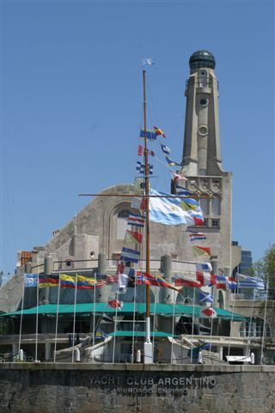

General Information

The name of the event
2015 F-18 World Championship Regatta

The year for the event
2015

Location for the event
Buenos Aires, Argentina

Hosting fleet, yacht club and organizing authorities

Yacht Club Argentino
www.yca.org.ar/
yca@yca.org.ar

ASOCIACIÓN ARGENTINA F-18

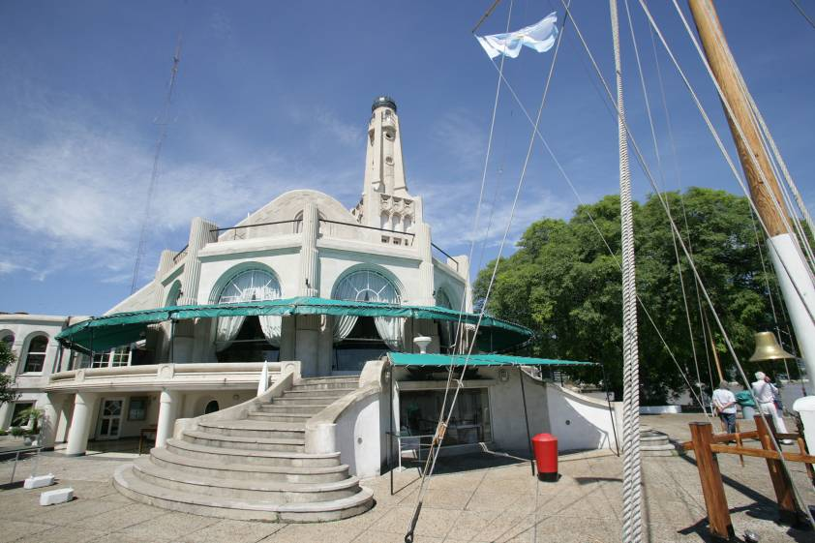

Event Contact

Yacht Club Argentino : Viamonte and Costanera Sur - Darsena Norte
(1170) Buenos Aires - Argentina - PO box: 4499 - VHF Station: LSD 49
Ph: (+ 54-11) 4314-0505 - Fax: (+ 54-11) 4312-9520
Darsena Norte Seat: 34º 35´ 48´´ S - 58º 21´ 48´´ W
E-mail: yca@yca.org.ar - http://www.yca.org.ar

Sailing Environment

The body of water where races will be held
The racing will be conducted on the waters of the “Rio de la Plata” river, in front of the Port of Buenos Aires.

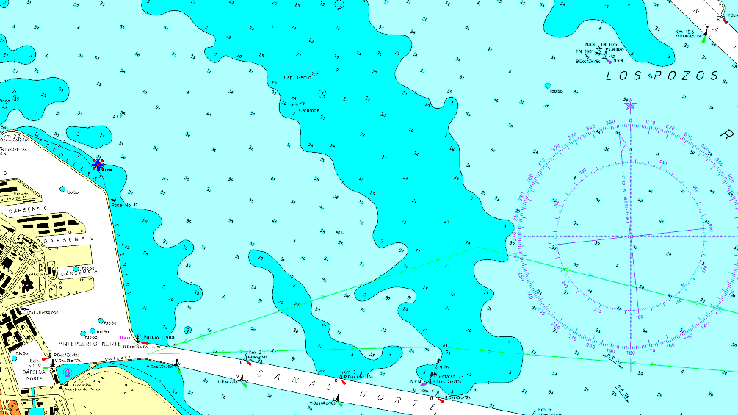

Distance and time to racecourses
The general racing area is approximately 3 miles from the docks at YCA . Transit time is estimated at 20 to 30 minutes.
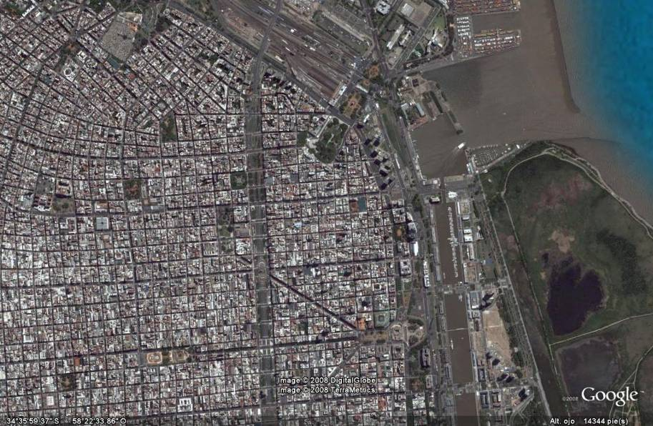

YCA

Obstructions on-route;
There are no man-made or natural obstructions on the route to or near the racecourse.

Proximity of landmasses
The racing area will provide race committee with different racecourses to choose from depending on conditions. Each offers a minimum of 3 miles of clear water in all directions.

Amount of current and direction
Typical flows are less than a knot. However, astronomical and/or meteorological influences can create stronger max flows.

Height in meters |  |  |  | Amplitude
Tide |  | Low tide
Max | Media | Min | Media | Max | Media
1,55 | 1,08 | 0,10 | 0,48 | 1,14 | 0,60

Weather and wind conditions expected

The climate of Buenos Aires is mild all year round. The mean annual temperature is 18º C (64.4º F), extremely hot and cold days are very infrequent.
In summer, the weather is hot and humid. Mornings are warm and during midday and the first hours of the afternoon, the temperature rises. At night, temperature goes down slightly.
Average temperature chart

Month | Temperature (°C) |  |  | Relative  Humidity  (%) | Winds media  (km/h) | Number of days with |  |  | Monthly  precipitation  (mm)
 | Máx media | Media | Mín media |  |  | Clear sky | Cover sky | Precipitation
Jan | 30.4 | 25.1 | 20.4 | 65 | 11.5 | 11 | 6 | 9 | 121.6
Feb | 28.7 | 23.7 | 19.4 | 70 | 10.8 | 11 | 6 | 9 | 122.6
Mar | 26.4 | 21.4 | 17.0 | 72 | 10 | 13 | 6 | 9 | 153.9
Apr | 22.7 | 17.7 | 13.7 | 77 | 8.9 | 11 | 6 | 9 | 106.9
May | 19.0 | 14.3 | 10.3 | 76 | 9 | 9 | 8 | 8 | 92.1
June | 15.6 | 11.2 | 7.6 | 79 | 8.4 | 9 | 10 | 6 | 50.0
July | 14.9 | 10.9 | 7.4 | 79 | 9.7 | 10 | 10 | 7 | 52.9
Ago | 17.3 | 12.7 | 8.9 | 74 | 10.3 | 9 | 9 | 8 | 63.2
Sep | 18.9 | 14.2 | 9.9 | 71 | 11.7 | 10 | 8 | 7 | 77.7
Oct | 22.5 | 17.7 | 13.0 | 69 | 11.5 | 11 | 7 | 10 | 139.3
Nov | 25.3 | 20.6 | 15.9 | 68 | 11.6 | 10 | 7 | 10 | 131.2
Dec | 28.1 | 23.2 | 18.4 | 64 | 11.8 | 10 | 6 | 9 | 103.2

The racing course is very challenging. The wind conditions vary significantly from day to day. Wind may be moderate from 8 to 15 knots from East to North, or strong up to 20 or 25 knots from Southeast or Southwest. Waves represent a challenge to sailors and the tide it is not very high but strong enough and very frequent.

Wind statics
Aeroparque Buenos Aires (BN_AIRES) this meteorological station is almost 4 miles from the race course.

Month | Jan | Feb | Mar | Apr | May | Jun | Jul | Aug | Sep | Oct | Nov | Dec | SUM
 | 01 | 02 | 03 | 04 | 05 | 06 | 07 | 08 | 09 | 10 | 11 | 12 | 1-12
Dominant Wind Direction
Wind statistics  > = 4 Beaufort (%) | 38 | 21 | 30 | 21 | 24 | 22 | 25 | 31 | 37 | 43 | 39 | 30 | 30
Average  Wind velocity (kts) | 10 | 8 | 9 | 8 | 8 | 8 | 9 | 9 | 10 | 10 | 10 | 9 | 9
Average air temp. (°C) | 25 | 25 | 23 | 20 | 16 | 12 | 12 | 12 | 16 | 19 | 22 | 25 | 18
Select month | Jan | Feb | Mar | Apr | May | Jun | Jul | Aug | Sep | Oct | Nov | Dec | Año
Wind direction  Distribution (%) | 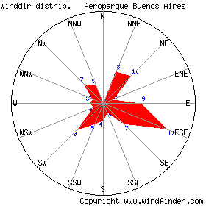

This graphic corresponds to the annual wind average direction. You can find the specific month at http://es.windfinder.com/windstats/windstatistic_buenos_aires.htm#
Average temperatures in Argentina (ºC)

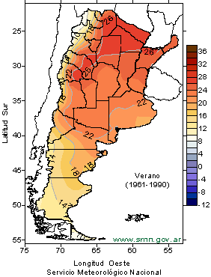

Entry Fee
The entry fee will be established between the International and National Class.

The entry fee will include:
• Storage of boats prior to the event
All participants are invited to Buenos Aires Sailing Week that will be held on our Yacht Club on October, therefore they can store their boats from that date.
• Launching and hauling prior to and after the event
• Dockage during the event at YCA’s facilities (required)
• Social activities as described in the Miscellaneous section
• Final awards, depth in keeping with class guidelines

There are no additional charges anticipated for the basic regatta activities.

Race Management

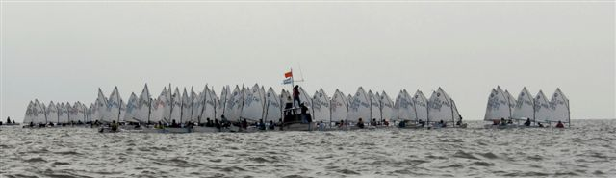

A listing of regattas that have been held
YCA has a long and prestigious track record of running class events. Some high-level regattas that YCA has organized and whose officials have presided over include:

Offshore World Championship Class I and II , Mar del Plata, 1978.
World Championship International Cadet Class, San Fernando, 1980.
Whitbread Round de World, Mar del Plata, 1982.
IBSA World Sailing Championship for Lechner , Raceboard and Division II, Buenos Aires 1990.
Offshore World Championship Class 3 (2 litres), Buenos Aires, 1990.
Offshore World Cup Class III (4 litres), 1992.
Offshore World Championship Class 3 (6 litres) and Class 2 , Mar del Plata 1992.
Panamerican Games, Mar del Plata 1995.
J/24 World Championship, Buenos Aires, 1997.
Optimist South American Championship, Buenos Aires, 1999.
470 South American Championship, 1999.
Europe South American Championship, 1999.
Stage Buenos Aires Global Challenge, 2004.
Odesur Games, Buenos Aires, 2006.
420 South American Championship, Buenos Aires, 2007.
Star South American Championship, Mar del Plata, 2007.
Match Race South American Championship, Buenos Aires, 2007.
Match Race Nations Cup Regional Final, Buenos Aires 2008.
Laser Central South American Championship, Mar del Plata, 2008.
International Class Cadet World Championship, Buenos Aires, 2009.
1st International Championship RG 65 Class, Buenos Aires, 2010.
International Class 420 World Championship, Buenos Aires, 2011
International Class Star South American Championship, Mar del Plata, 2011.
International Class Soling South American Championship, Buenos Aires, 2012.
International Class F-18 South American Championship, Buenos Aires, 2012.
International Class 470 South American Championship, Buenos Aires, 2012.
International J-24 Class World Championship, Buenos Aires, 2012.
International Laser Class Central and South American Championship, Buenos Aires, 2012.
International Laser 4.7 Class Youth World Championship, Buenos Aires, 2012.
International Laser Standard Class Under 21 World Championship, Buenos Aires, 2012.

Every year, it holds the “Semana de Buenos Aires”, included in the ISAF Ranking.
Over the month of October, an average of 700 boats sailed by 1000 people of different ages meet at the Darsena Norte seat to participate of this “must race” event. Optimist, Cadet, Laser, Europe, Snipe, 420, 470, 29er, Soling, J24, Star, OD-27, Soto 33 and Grumete sailors come from everywhere in Argentina, and from neighboring countries to race this championship.
The ISAF has recognized the importance of this event by including it on its Official World Sailing Ranking as grade 3.

Also, every year, the YCA holds many ocean races as:
Circuito Atlántico Sur Rolex Cup
Ocean Race Rolex Buenos Aires – Rio de Janeiro
Ocean Race Buenos Aires - Mar del Plata
Ocean South American Championship

Make-up of race committee

YCA is recognized throughout the sailing world for the quality of its personnel and overall race management skills.
When staffing an event like the F-18 Worlds, the vast majority of on-the-water positions will be filled with dedicated race management officers. This translates to quality knowledgeable staff from main committee, to the weather mark, to all the various support boats.

Equipment that will be used

The Yacht Club Argentino has been organizing regattas for more than one hundred years. It has an excellent reputation between the South American sailors for its strong infrastructure and the seriousness with which it carries out every championship.
YCA owns all its own race management equipment. This includes:

o Marks
o Signals
o Ground tackle
o Navigation equipment
o Communications equipment
o A variety of support boats

All YCA race committees are skilled in the utilization of GPS in setting and maintaining proper courses. YCA also uses to up date information on real time on its web site and post on it many good photographs of its events.

Number of and level of jury to be convened
An international jury will be convened for this event. International judge Gonzalo Heredia will handle the solicitation and staffing of this group.

Measurement facilities

The facilities at YCA will greatly contribute to organizing the measurement process. The drive-through grounds and large enclosed spaces will make boat measurement and sail measurement stations easy set up and move through. The overall effect should simplify the process for both competitors and measurers.

Boats & Other Marine Related

Launching facilities;
YCA’s amenities includes:

• 3 hoists – 1 @ 1 ½ -ton, 1 @ 1-ton and 1@ 9-ton
• Space for 250 in land dinghies
• Drive through grounds
• On-site facilities for sail measurement
• Ample parking
• Multiple bath and shower facilities

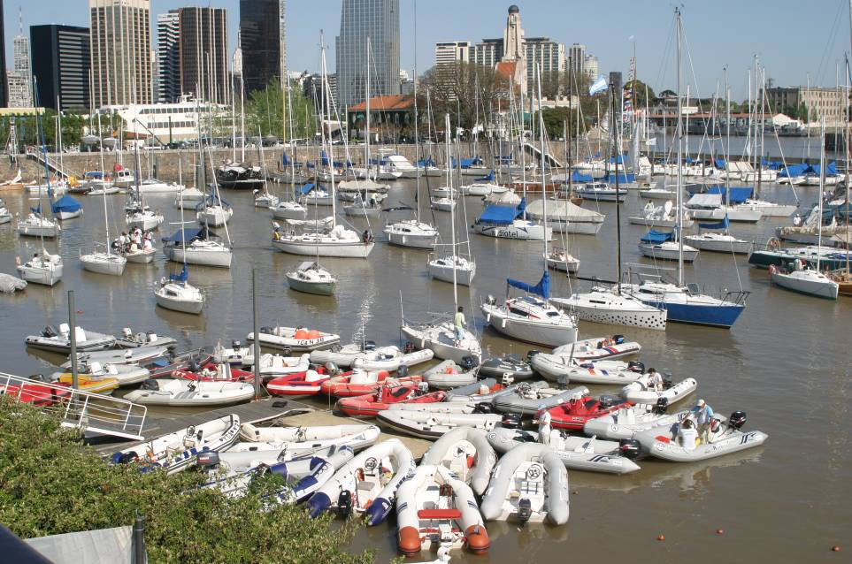

Location of marine supply and repair shops
Buenos Aires’ international reputation as boating center has its advantages when you need supplies or repairs.
We will have on the sailing center representatives of sail markers and a truck workshop with supplies.

Dozens of marine repair facilities, several within walking distance of the sailing center.

Mooring facilities
All boats will be berthed at the YCA sailing center. This offers an equal degree of convenience for all competitors. A single facility improves the organizing authority’s ability maintain control and organize off-the-water activities. Communications with the fleet are improved and it also promotes a more social atmosphere.

Charter boats
To help to facilitate charters, the organizing committee will establish a centralized information portal, that will give competitors and owners convenient means to reach each other.
Boat Transportation

Nearest port for shipment of boats
The port of Buenos Aires is 3 miles from the Yacht Club Argentino. This is Argentina major ports and receives containerized shipments from around the globe.

Crew Transportation

Airports
Two airports serve the city:
Ezeiza International Airport. Visitors from the rest of the world are welcomed at this airport located 15 minutes away from downtown through a highway.
Jorge Newbery Airport. Tourists coming from the interior of the country or from bordering countries arrive at this airport located by the riverside, five minutes away from downtown.
Both of them offers taxi, remise, transfer and bus services 24 hours a day.

Transportation from airport
Two airports serve the city:
Ezeiza International Airport. Visitors from the rest of the world are welcomed at this airport located 15 minutes away from downtown through a highway.
Jorge Newbery Airport. Tourists coming from the interior of the country or from bordering countries arrive at this airport located by the riverside, five minutes away from downtown.
Both of them offers taxi, remise, transfer and bus services 24 hours a day.

Accommodation

Type and distance of available accommodation
Buenos Aires has a wide variety of lodging alternatives, the city can provide accommodation to more than 5 million tourists every year. There are over 40 hotels within walking distance from the Yacht Club Argentino and the offer is diverse in comfort and prices.
On the Appendix you will find from five stars hotels to cheap hostels for tight budgets all walking distance from the club.
DOWN

TOWN
YCA

Shore Based Details

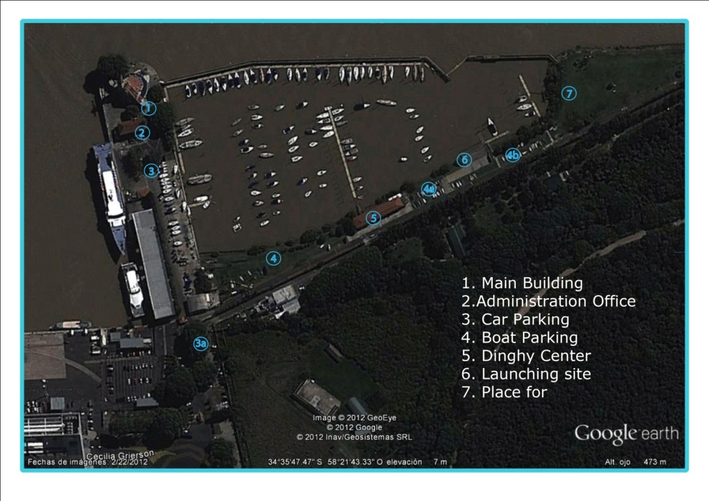
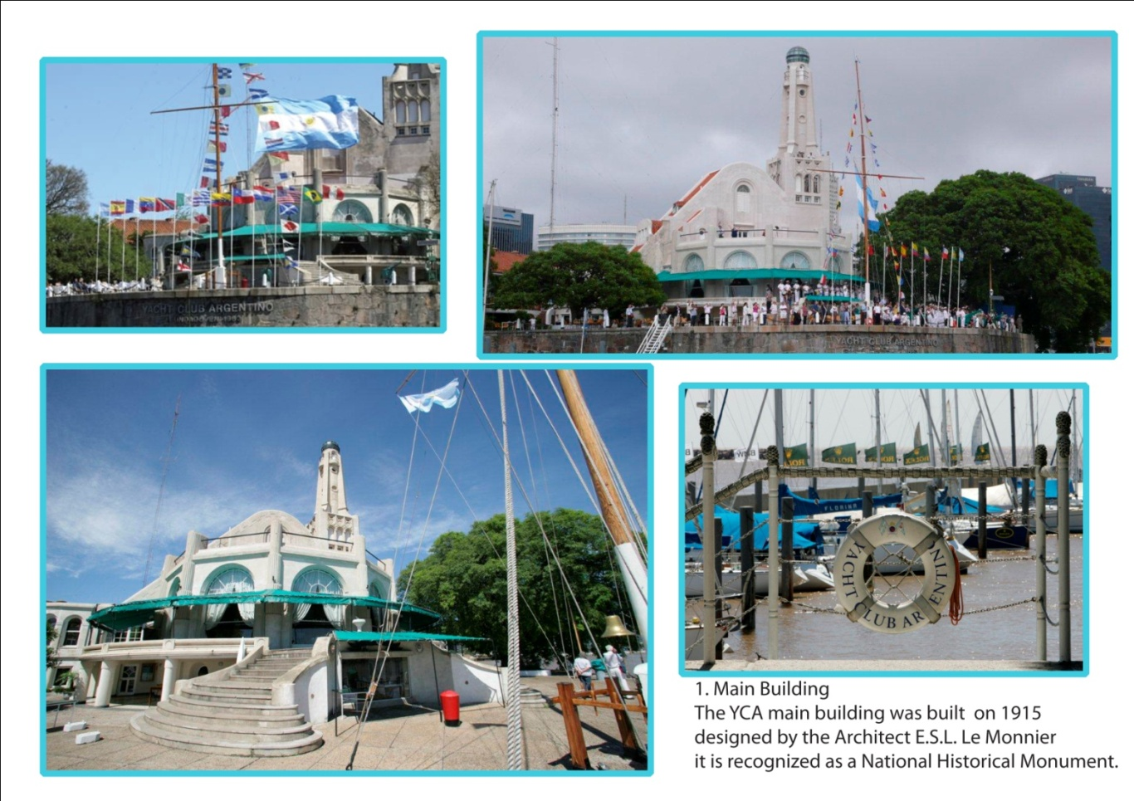

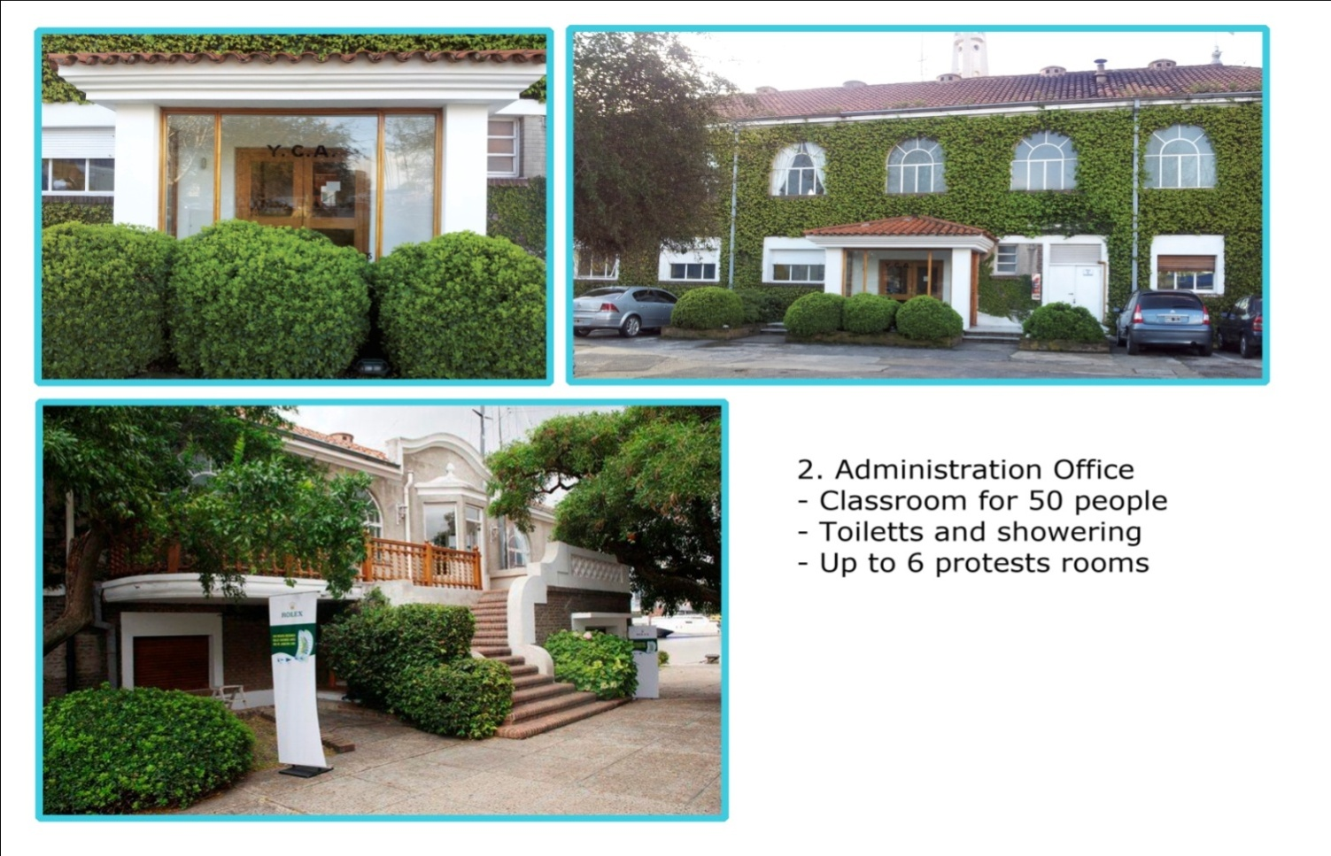

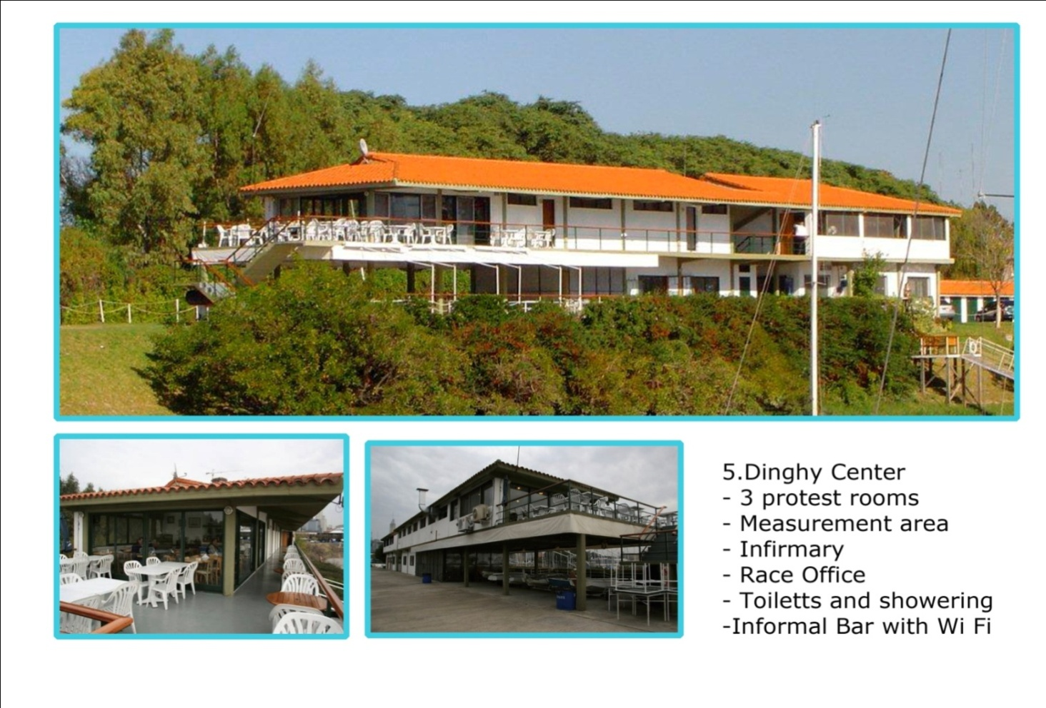

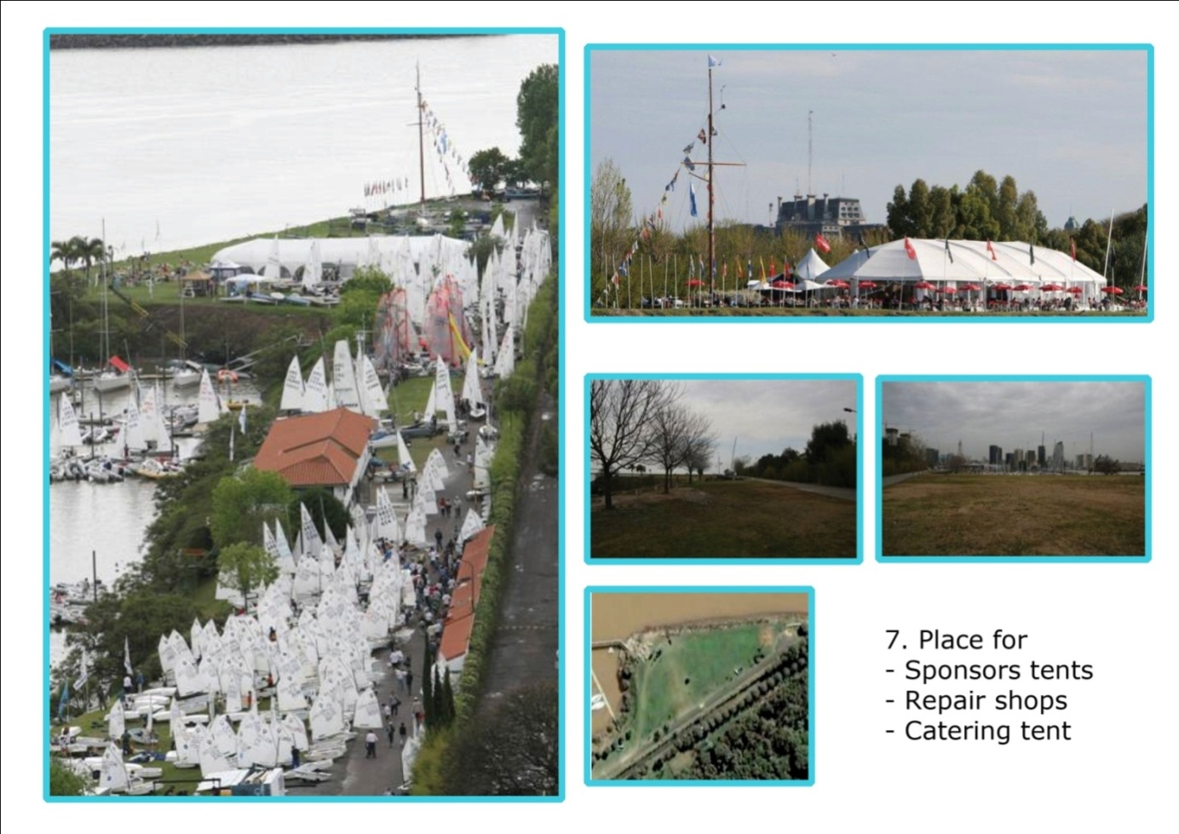

This is the Dinghy sailing center:

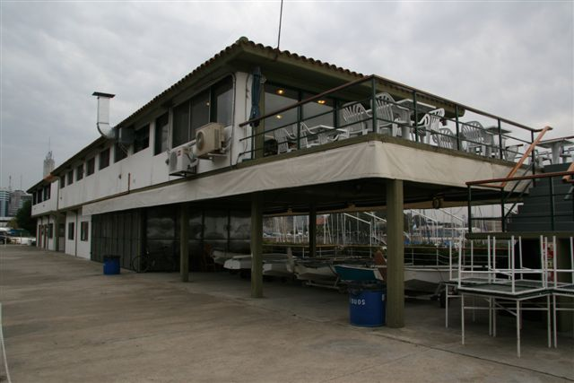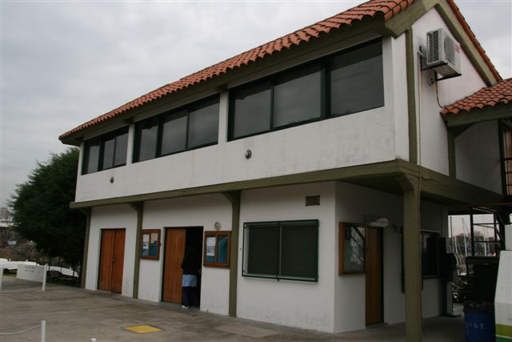

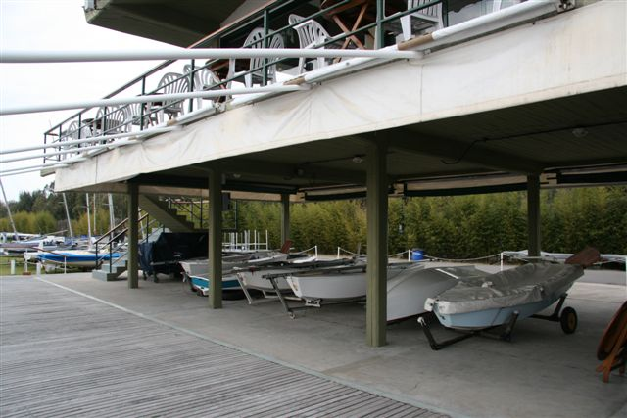

This is the space that we use to do the measurement. It has plastic courtains all around so we can close it in windy or rainy days.

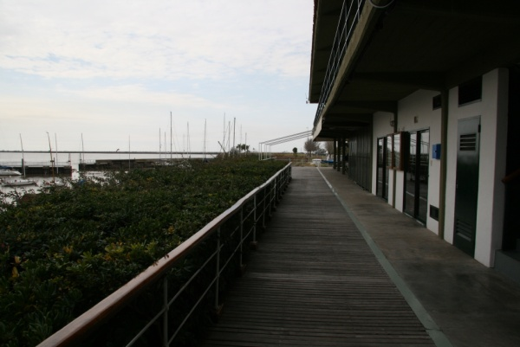

Part of the deck in front of the race office.
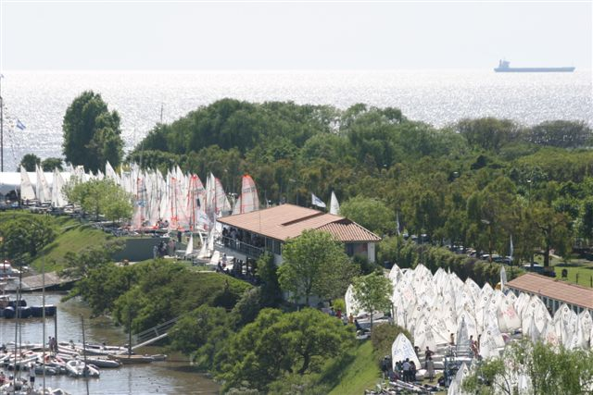

Launching / landing sites

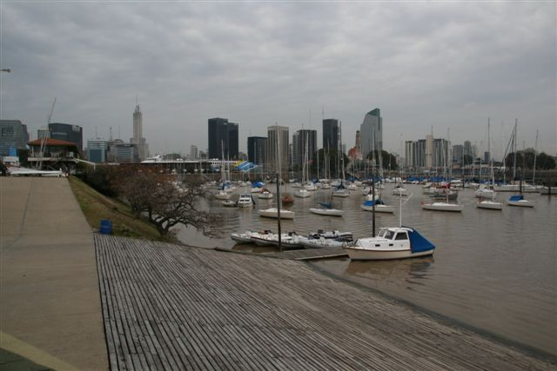
Launching aerea
Dinghy Center

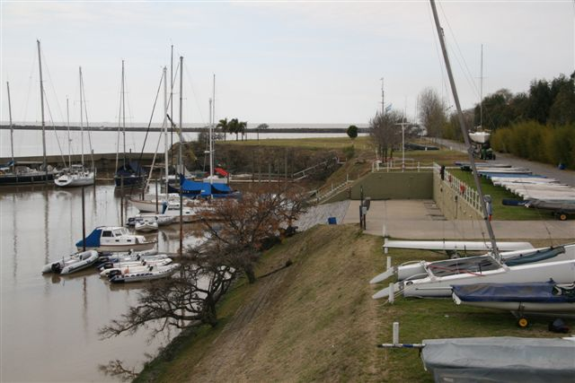

We have no limitation from weather conditions or sea states to launch the boats. We have electronic control with magnetic cards for the check in and out on the launching site also we have four pipes hose and four electrical connections on the ramp.

Electronic control:

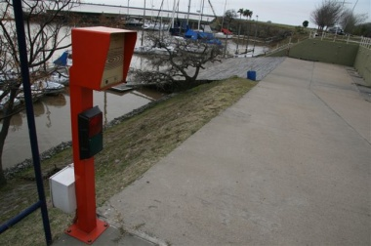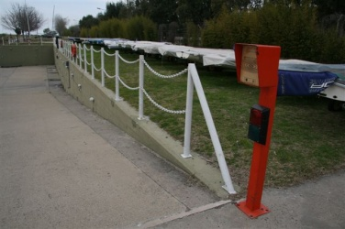

Pipe hoses and electric connection:

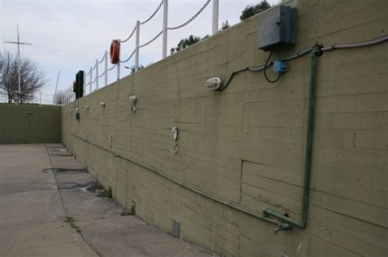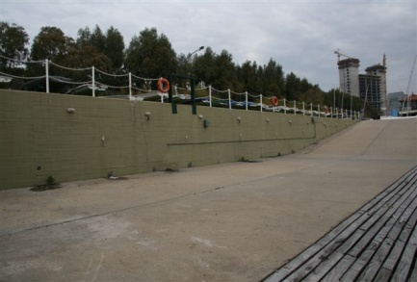

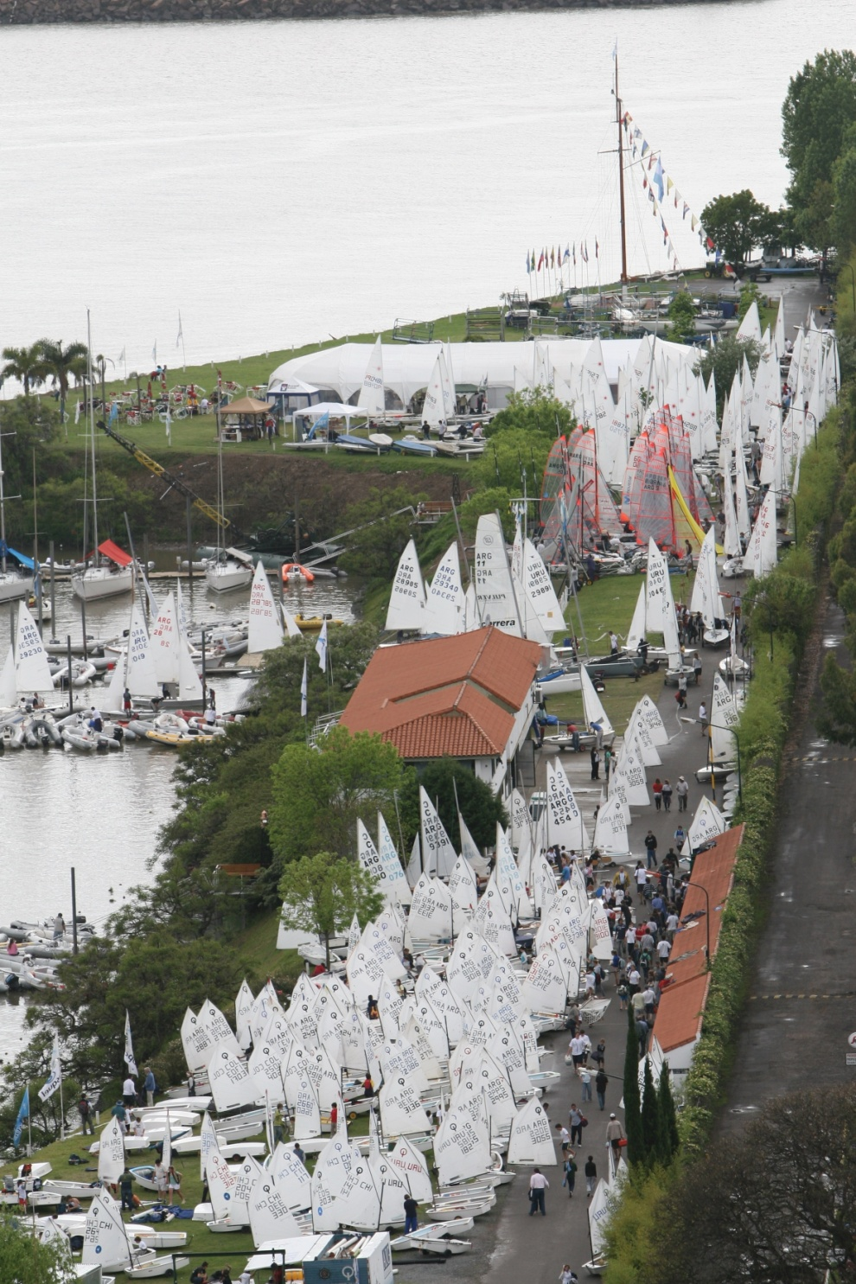
Electrical connection
Electrical connection
Electrical connection
Fresh water hose pipes
Fresh water hose pipes
Fresh water hose pipes

Facilities
The sailing center at YCA has showers and head facilities. Both are secure requiring combinations to gain access. We are able to lodge containers for storage sails and other boat equipment. The YCA has 24hs. security guards during all the year

The Competitors Village has an outdoor and indoor informal Bar with Wi-Fi.

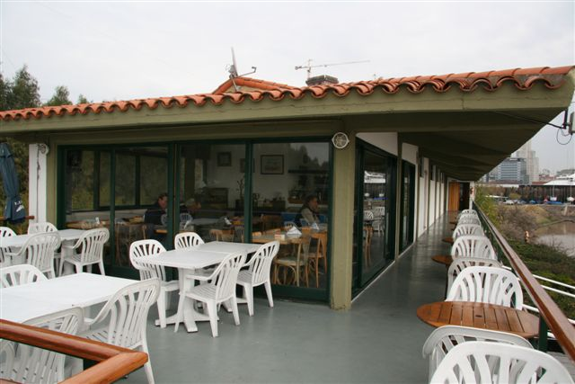

Press
The Yacht Club Argentino has its own web site www.yca.org.ar where all championship results and press were posted daily. YCA uses to up date information on real time on its web site and post on it many good photographs of its events. For the J-24, Laser 4.7 Youth World Championship, Laser Standard Under 21 World Championship and Semana de Buenos Aires we created specifics sites. We do also use facebook and twitter to share the instant information on our important events.
We invite you to look at our site: http://www.laserworld2012.org.ar/ we used on the Laser 4.7 Youth World Championship and the Laser Standard Under 21 World Championship or the http:/ /www.yca.org.ar site.
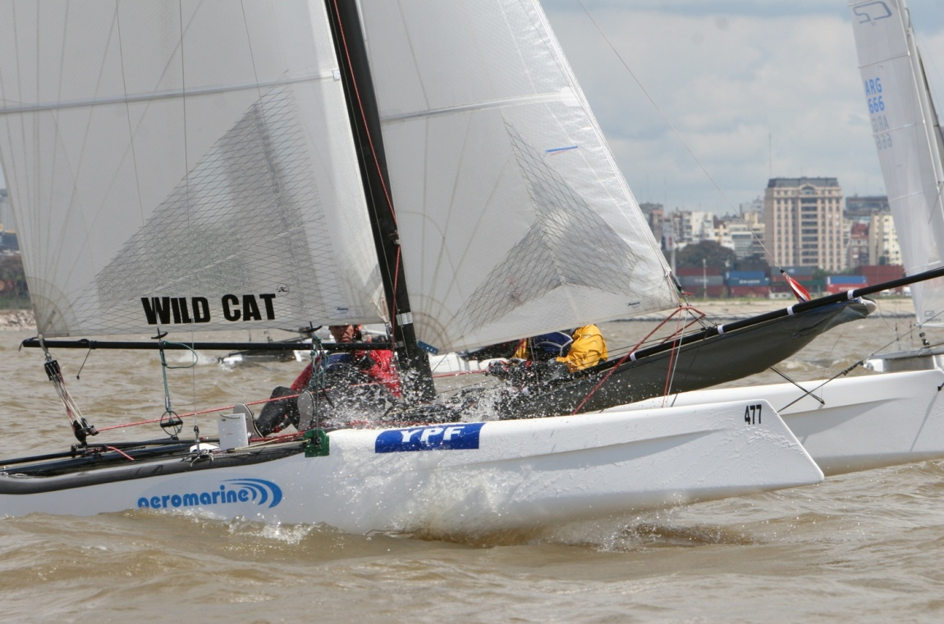
Miscellaneous

Types of social events planned

• Daily:
• Deck Party (on the sailing center)

• Special Regatta Events:
• Opening ceremony
• Closing ceremony

• Potential Non-Regatta Events:
• Semi organized activities at establishments for food and drink on nights with no formal event planned
. Mid week formal party with dinner.

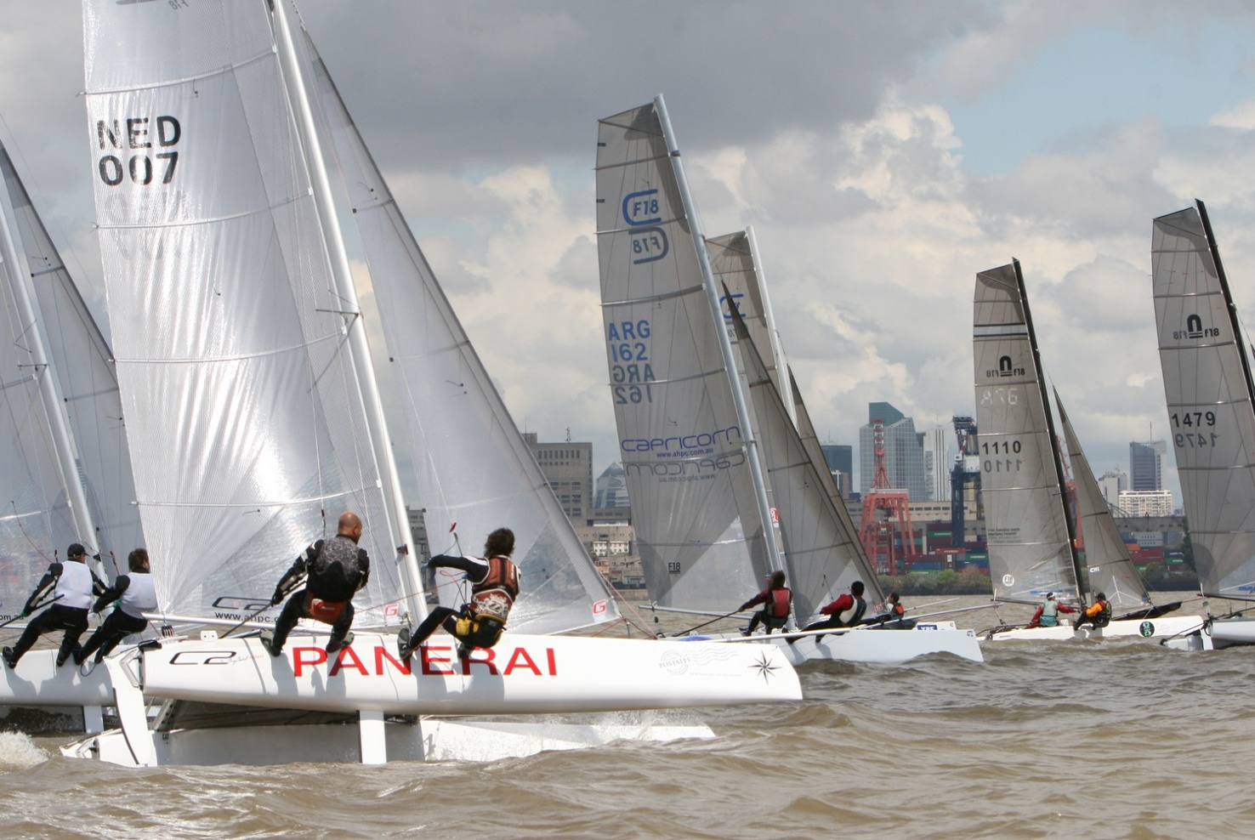

Tourism information in Puerto Madero
Alicia Moreau De Justo 200 Dique 4
(54 11) 4315 4265
Hours: monday to sunday from 10am to 6pm.

WHERE TO STAY IN BUENOS AIRES

Neighborhood Puerto Madero

Category: 5 stars

Hilton
Address: Macacha Güemes 351
(54 11) 4891 0000 hiltonba@mail.com

Category: 4 stars

Hotel Madero
Address: Rosario Vera Peñaloza 360
(54 11) 5776 7777
info@hotelmadero.com

Neighborhood Recoleta

Category: 5 stars

Alvear Palace Hotel
Address: Av. Alvear 1891
(54 11) 4808 2100
info@alvearpalace.com

Loi Suites Recoleta Hotel
Address: Vicente López 1955
(54 11) 5777 8950
recoleta@loisuites.com.ar

Sofitel Buenos Aires
Address: Arroyo 841 / 849
(54 11) 4131 0000
h3253@accor.hotels.com

Category: 4 stars

Wilton Palace Hotel
Address: Av. Callao 1162 / 64
(54 11) 4811 1818 / 1993
info@hotelwilton.com.ar

Kempinski Park Elegance
Address: Av. Pueyrredón 1940
(54 11) 4777 0500
elegance@parkplazahotels.com

Meliá Recoleta Plaza Boutique Hotel
Address: Posadas 1557
(54 11) 5353 4000 melia.recoleta.plaza@solmelia.com

Kempinski Hotel Park Plaza
Address: Parera 183
(54 11) 6777 0200
park@parkplazahotels.com

Category: 3 stars

Bel Air Bs. As. Hotel
Address: Arenales 1462
(54 11) 4021 4000
reservas@hotelbelair.com.ar

Plaza Francia Hotel
Address: Eduardo Schiaffino 2189
(54 11) 4804 9631
reservas@hotelplazafrancia.com

Ayacucho Palace Hotel
Address: Ayacucho 1908
(54 11) 4806 1815
reservas@ayacuchohotel.com.ar

Guido Palace Hotel
Address: Gral. Guido 1780
(54 11) 4812 0674 / 0841
consulta@guidopalace.com.ar

Hotel Principe
Address: Laprida 1454
(54 11) 4821 9818
principe@hotel-principe.com.ar

Recoleta Hotel
Address: José L. Pagano 2685
(54 11) 4802 7318
hotelrecoleta@elsitio.net

Category: 1 and 2 stars

Alfa
Address: Riobamba 1064
(54 11) 4812 2889 / 3719
reservas@alfahotel.com.ar

Omega
Address: Paraguay 2991
(54 11) 4824 4431
hotelomega@arnet.com.ar

El Castillo Hotel
Address: Marcelo T. de Alvear 1893
(54 11) 4813 2048 / 815 4561 recepcion@hotelelcastillo.com.ar

Prince Hotel
Address: Arenales 1627
(54 11) 4811 8004
princehotel@arnet.com.ar

Hotel Onze Boutique+Vanguardia Address: Ecuador 1644
(54 11) 4821 2873
info@onzehotelboutique.com

Category: Appart hotel

Designes Suites
Address: Marcelo T. de Alvear 1683
(54 11) 4814 8700
marketing@designesuites.com

Apart Recoleta Ar
Address: Gral. Guido 1984
(54 11) 4801 8003
hotel@apartrecoleta.com.ar

Ulises Recoleta
Address: Ayacucho 2016
(54 11) 4804 4571 / 72 / 0734 / 0737
ulisesrecoleta@comnet.com.ar

L' Etoile
Address: Pte. Roberto M. Ortíz 1835
(54 11) 4804 8603 / 4805 3613
hotel@etoile.com.ar

Trianon Residence
Address: Av. Callao 1869
(54 11) 4811 3601 / 5403 / 9789
info@trianon.com.ar

Urban Suites
Address: Junin 1727
(54 11) 4803 2300
info@urbanrecoleta.com

Design CE
Address: Marcelo T. de Alvear 1695
(54 11) 5237 3100
info@designce.com

Loi suites Esmeralda
Address: Marcelo T. de Alvear 842
(54 11) 4131 6800
edesmare@loisuites.com.ar

Neighborhood: Retiro

Category: 3 stars

Waldorf
Address: Paraguay 450
(54 11) 4312 2071 al 78
info@waldorf-hotel.com.ar

